Gentian Hoxha

IT-640 Telecommunications and Networking

Milestone Two

[Gentian.hoxha@snhu.edu](mailto:Gentian.hoxha@snhu.edu)

SNHU Energy Project Analysis Plan + Network Architecture

**Introduction**

In this project we are going to discus about how SNHUEnergy, Inc.'s network looks right now, and how the Open Systems Interconnection (OSI) model kinda fits into it. The company's network helps them keep important stuff like HR, payroll, billing, and operations up and running across two main places - Dallas and Memphis. Even though the current setup mostly gets the job done, there’s few things that could cause trouble if the company grows. So here we take a closer look at how the network is built, the traffic that flows around, and where there could be some problems.

**Physical Network Devices**

The network at SNHUEnergy uses a bunch of important gadgets:

* **Routers:** They connect Dallas, Memphis, and the main office to each other through VPNs on the internet.
* **Switches:** Handle the local traffic inside each office, connecting computers, printers, and servers.
* **Firewalls:** Keep the Dallas and HQ safe by filtering traffic, but Memphis ain't got one yet.
* **Access Points:** Lets people connect to the network wirelessly.
* **Servers:** Run the important apps like SQL databases and VoIP servers, which are mostly at the HQ.
* **Endpoints:** All the computers, phones, laptops, and printers that people use everyday.

**Critical Traffic Patterns**

Important types of traffic zooming around their network:

* **Voice over IP (VoIP):** Voice calls get managed through special protocols and most of the action goes through HQ.
* **Application Traffic (SQL):** People in Dallas and Memphis talk to the main SQL database sitting at HQ.
* **Network Management Traffic:** IT guys use SNMP and RDP to manage devices remotely.
* **Other Traffic:** File sharing and logging in happens over SMB and LDAP protocols.

**Patterns Across the Infrastructure**

* Both Dallas and Memphis hook up to HQ using VPN tunnels.
* SQL database queries and VoIP calls all go through HQ.
* Remote management like RDP happens from HQ out to the branch offices.

Because everything goes through HQ, it’s kind of like a choke point, which could be a bad thing if the company keeps growing.

**Performance Issues**

Here’s some stuff that might go wrong if they don't fix it:

* **VPN Bottleneck:** Too much traffic could clog up the VPNs, slowing down everything.
* **Latency and Jitter:** Real-time things like VoIP and video calls might get choppy.
* **Single Point of Failure:** If HQ goes down, everyone else is stuck.
* **Bandwidth Saturation:** Growing more without getting bigger pipes will make everything slower.

**Example:** If too many people are working at the same time in Memphis, their payroll app might crash or get super slow.

**Security Issues**

Big security risks if they keep rolling like this:

* **Memphis Office Vulnerability:** No firewall means hackers might just walk right in.
* **HQ Compromise Risk:** If something bad happens at HQ, every office is at risk.
* **Weak VPN Security:** If the VPNs aren't locked down real good, attackers could snoop on data.
* **No Backup Links:** One path means no plan B if it fails.

**Example:** A hacker could attack Memphis' router, then creep into the whole network since they don’t have enough defenses.

**Visual Representation**

A diagram visual representation of the output of the traffic flows in the project.

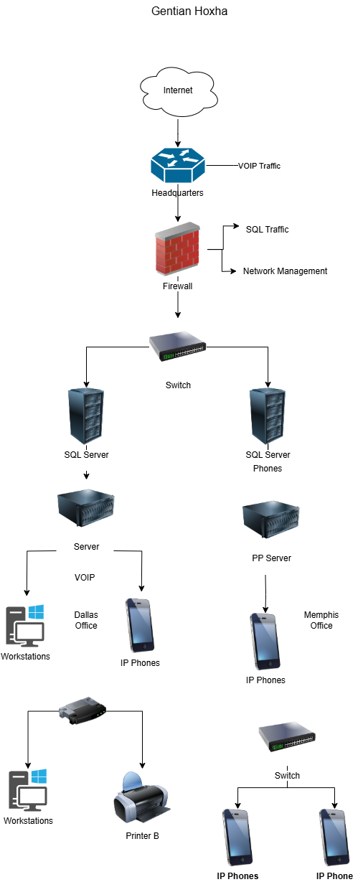

**Citations**

uCertify. (n.d.). *Chapter 2: Networking basics*. uCertify. <https://www.ucertify.com/app/?func=ebook&chapter_no=2#top>

uCertify. (n.d.). *Chapter 3: OSI model*. uCertify. <https://www.ucertify.com/app/?func=ebook&chapter_no=3#top>

uCertify. (n.d.). *Chapter 3: Protocols and standards*. uCertify. <https://www.ucertify.com/app/?func=ebook&chapter_no=3#076jw>

uCertify. (n.d.). *Chapter 10: Network security*. uCertify. <https://www.ucertify.com/app/?func=ebook&chapter_no=10#top>

uCertify. (n.d.). *Chapter 11: Troubleshooting and monitoring*. uCertify. <https://www.ucertify.com/app/?func=ebook&chapter_no=11#top>

Mitchell, C. (2021, April 13). *Near the heart of Silicon Valley, a community failed by the big internet providers is building its own network*. Institute for Local Self-Reliance. <https://ilsr.org/articles/near-the-heart-of-silicon-valley-a-community-failed-by-the-big-internet-providers-is-building-its-own-network/>

Southern New Hampshire University. (2025). *IT 640 Memphis Office Network Diagram – Current* [PDF]. SNHU. <https://learn.snhu.edu/content/enforced/1894272-IT-640-10526.202518-1/Course%20Documents/IT%20640%20Memphis%20Office%20Network%20Diagram%20Current.pdf?isCourseFile=true&ou=1894272>

Southern New Hampshire University. (2025). *IT 640 Dallas Office Network Diagram – Current* [PDF]. SNHU. <https://learn.snhu.edu/content/enforced/1894272-IT-640-10526.202518-1/Course%20Documents/IT%20640%20Dallas%20Office%20Network%20Diagram%20Current.pdf?isCourseFile=true&ou=1894272>

Southern New Hampshire University. (2025). *IT 640 Organizational Network Diagram – Current* [PDF]. SNHU. <https://learn.snhu.edu/content/enforced/1894272-IT-640-10526.202518-1/Course%20Documents/IT%20640%20Organizational%20Network%20Diagram%20Current.pdf?isCourseFile=true&ou=1894272>